

National University of Computer & Emerging Sciences,
Karachi
Fall 2026, Lab Manual

Introduction to Object-Oriented Programming (Lab)

Course code :
Instructor : | Shahzaib Shaikh

Lab Title
Python Environment Setup & OOP Orientation
Lab Activities
- Setting up the Python development environment using VS Code or PyCharm.
- Writing and executing a first Python program.
- Reviewing the difference between procedural programming and object-oriented programming (OOP).
- Understanding the basic concepts of classes and objects.
- Initializing the folder structure for the Wallet Project.
Lab Objectives
By the end of this lab, students will be able to:
- Install and verify Python on their computer.
- Set up a Python development environment using VS Code or PyCharm.
- Create, save, and execute a Python program.
- Understand the basic difference between procedural and object-oriented programming.
- Identify classes, objects, attributes, and methods.
- Create an organized folder structure for a Python project.
- Prepare the initial workspace for the Wallet Project.

Required Software and Tools
- Python 3.x
- Visual Studio Code or PyCharm
- Python extension/plugin for the selected IDE
- Terminal/Command Prompt
- A computer with Windows, macOS, or Linux

Environment Setup

Step 1: Verify Python Installation
Open the terminal or command prompt and execute:
python --version
If that does not work, try:
python3 --version
A successful installation should display a Python 3.x version.

Expected Result
You should see output similar to:
Python 3.x.x

Step 2: Set Up VS Code
If using Visual Studio Code:
- Install and open VS Code.
- Install the Python extension.
- Create a new folder for the lab.
- Open the folder in VS Code.
- Select the installed Python interpreter.
- Create a new file named:
- main.py

Step 3: Set Up PyCharm
If using PyCharm:
- Install and open PyCharm.
- Select New Project.
- Choose Python as the project language.
- Select or create a Python interpreter/virtual environment.
- Give the project an appropriate name.
- Create the project.

Background Theory

Programming?

Programming is the process of giving step-by-step instructions to a computer to tell it what to do.

Python Programming?
Python is a high-level, general-purpose programming language known for its simple syntax and readability. It supports several programming paradigms, including procedural, functional, and object-oriented programming.
A simple Python program is:
print("Hello, World!")
The print() function displays information on the screen.
Types of Programming:
  - Procedural Programming
  - OOP(Object-Oriented Programming)

Procedural Programming
In procedural programming, a program is generally organized as a sequence of instructions and functions.
Or
A programming paradigm where a program is organized primarily around functions/procedures that operate on data.
Example:

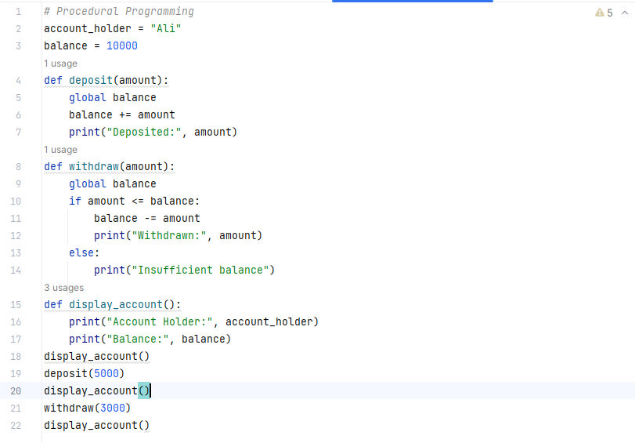

Here, the data and functions that operate on the data are handled separately.

What is happening?
Here we have:
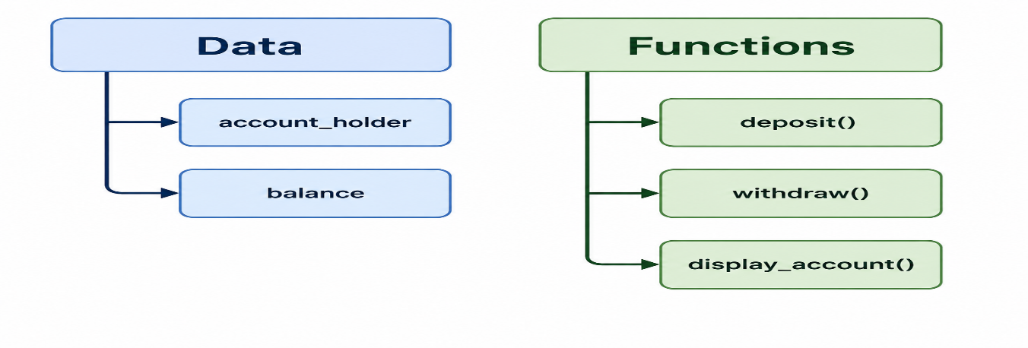
The functions operate on the global variable: balance

The data and functions are separate.
The data and functions are separate.

Object-Oriented Programming
Object-oriented programming organizes a program around objects. An object contains data and behavior.
Or
A programming paradigm where a program is organized around objects that combine data and behavior.
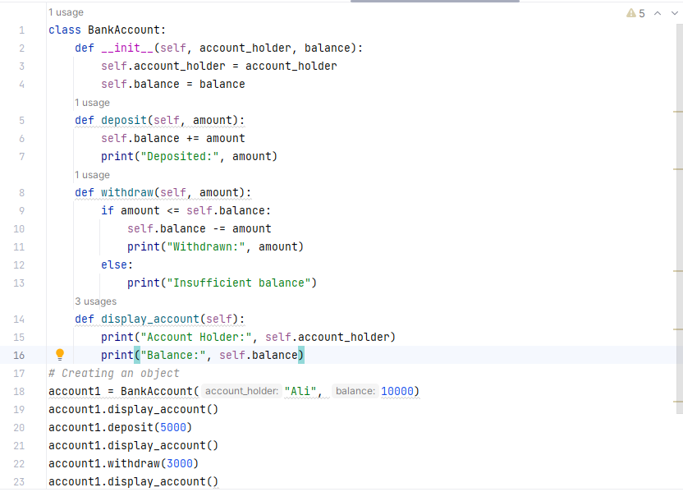
For example, a wallet can be represented as an object.

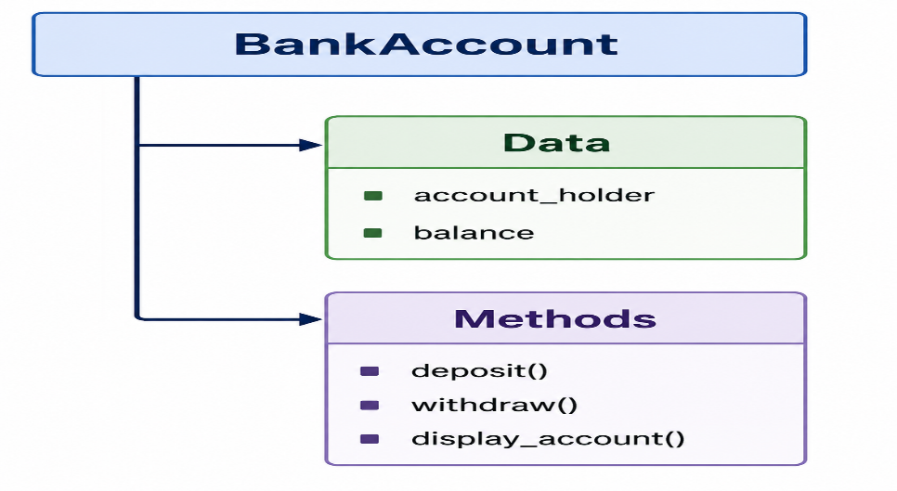
Now the structure is different:

Here data and functions are bundled together inside a class.

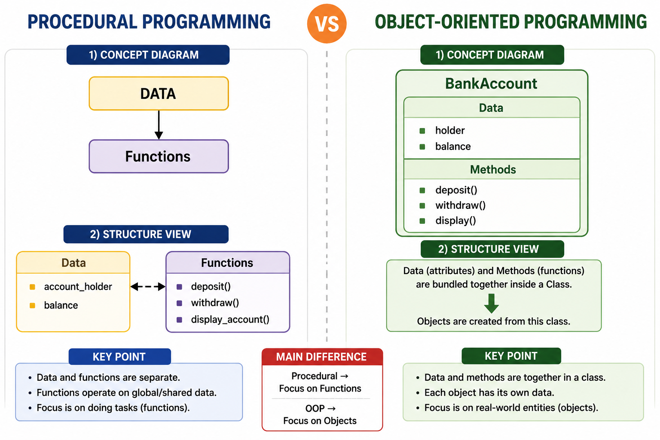
Difference between Procedural and OOP Programming

OBJECT AND CLASS
Object
Represents an entity which possesses certain features and behaviors.
An object represents a real-world entity.
Any tangible or touchable entity in the real-world can be described as an object.
Simple Real-World Example
To better understand how features (attributes) and behaviors (methods) work, consider a Car:
- Features/Attributes (What it is): Brand, color, model, top speed.
- Behaviors/Methods (What it does): Accelerate, brake, turn, honk.
The Relationship with a Class
- Class: The blueprint, factory, or template (e.g., the architectural blueprint of a house).
- Object: The actual physical instance created from that blueprint (e.g., the specific brick-and-mortar house you can live in).

Each Object has:
Characteristics - Defined as attributes, properties, or features describing the object.
Actions - Defined as activities or operations performed by the object.
Example of an object, Dog.
→ Properties - Breed, Color, and Age
→ Actions-Barking, Eating, and Running
The concept of objects in the real-world can be extended to the programming world where software 'objects' can be defined.
Class
It is a template that is used to create objects of that class.
In the real-world, several objects:
Have common state and behavior.
Can be grouped under a single class.
Example: All car objects have attributes, such as color, make, or model.
Class:
Can be defined that a class is a template or blueprint which defines the state and behavior for all objects belonging to that class.
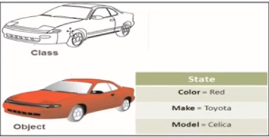

Importance of OOP in FinTech
- Banking software
- Wallet apps (Easypaisa, JazzCash)
- Trading systems
- Payment gateways
Procedural Programming Task .
Task 1 A BANK ACCOUNT MANAGEMENT
A bank wants a simple program to manage customer bank accounts.
The program should store information about a customer's name, account number, and balance.
The program should allow the user to:
- Create an account
- Deposit money
- Withdraw money
- Check account balance
- Display customer information

For withdrawal, the program should check whether the customer has sufficient balance. If the balance is insufficient, display an appropriate message. And Create 10 accounts and show All Accounts Summery in Last

Task 2 — Number Analysis
Concepts: for loop, while loop, conditions
Write a Python program that asks the user to enter 10 numbers.
Your program should:
- Store the numbers.
- Count how many numbers are positive.
- Count how many are negative.
- Count how many are zero.
- Calculate the sum of all numbers.
- Find the largest number.
- Find the smallest number.
Do not use max() or min().

Task 3 — Student Marks List
Concepts: List, loops, conditions
Create a program that asks the user to enter marks of 10 students and stores them in a list.
The program should display:
- All marks
- Highest marks
- Lowest marks
- Average marks
- Number of students who passed
- Number of students who failed

Task 4 — Shopping List
Concepts: Lists, loops, conditions
Create a simple shopping program.
The user should enter 5 products and their prices.
Store the products and prices in lists.
Then calculate:
- Total bill
- Most expensive product
- Cheapest product
- Average product price

Task 5 — Tuple-Based Student Record
Concepts: Tuple, list, loops
Create student records using tuples.
Store these tuples inside a list:
Your program should:
- Display all students.
- Display only student names.
- Display students whose age is greater than 20.
- Count the number of students.
- Search for a student by name.

Task 6 — Functions-Based Calculator
Concepts: Functions, conditions, loops
Create a calculator using separate functions:
Display a menu:
- Addition
- Subtraction
- Multiplication
- Division
- Exit
The program should continue running until the user selects Exit.
Division by zero must be handled.

Task 7 — List Processing Using Functions
Concepts: Lists + loops + functions
Create the following functions:
- calculate_sum(numbers)
- calculate_average(numbers)
- find_largest(numbers)
- find_smallest(numbers)
- count_even(numbers)
- count_odd(numbers)
Ask the user to enter numbers and store them in a list.
Don't use built-in sum(), max(), or min().

